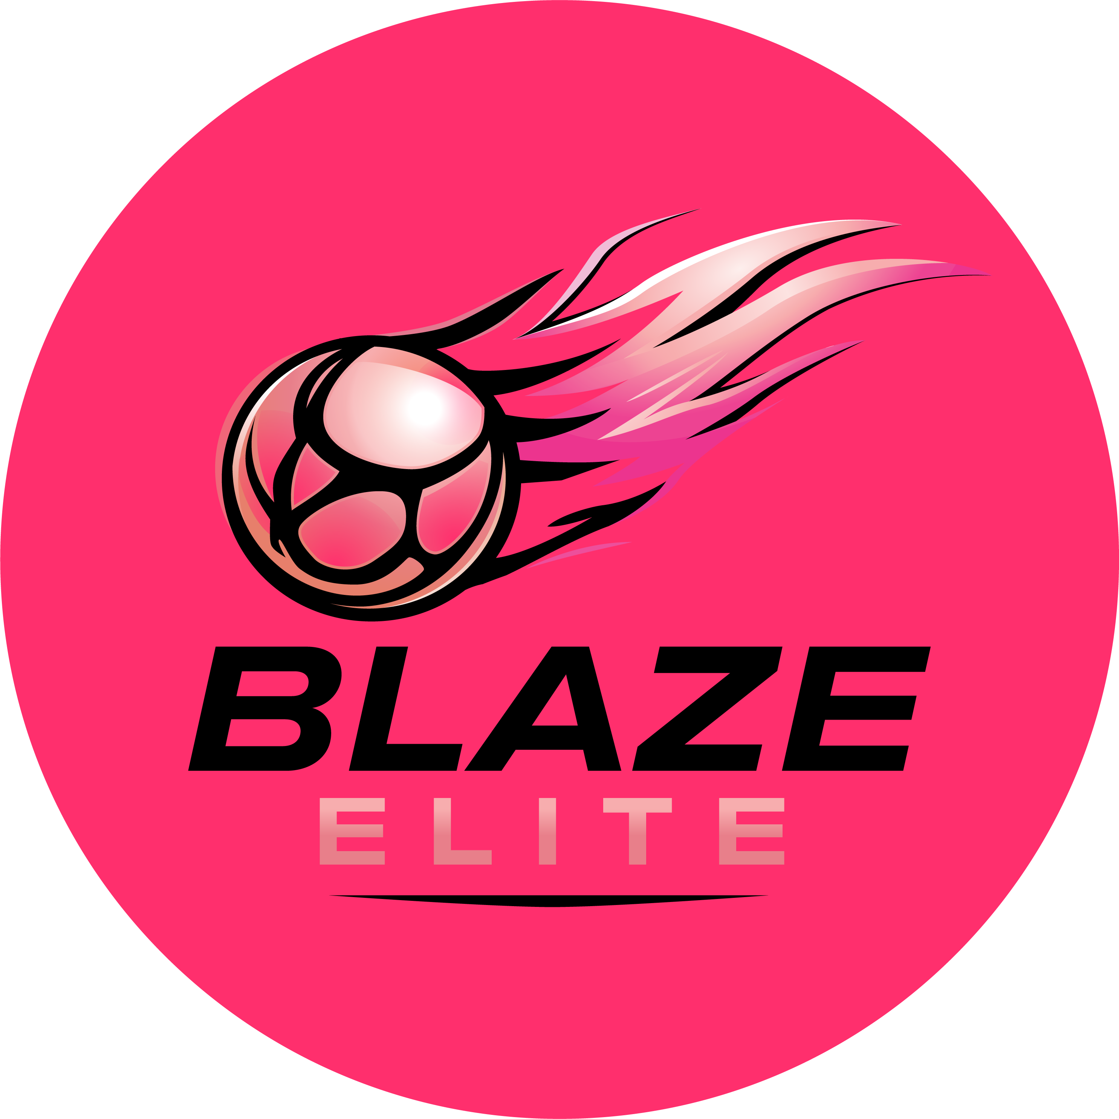

Safeguarding & Child Protection Policy
Blaze Elite Netball Club

1. Policy Statement
Blaze Elite accepts its duty of care for every young athlete in our club. Netball is for all, and the club should be a place where athletes are safe and feel safe, and where anyone is able to raise concerns or challenge behaviour without fear or retribution.
This policy applies to all coaches, committee members, volunteers, parents/guardians and athletes at Blaze Elite, and it is the responsibility of everyone involved to comply with it and, when necessary, report concerns.

2. Basic Principles
- Anyone under the age of 18 is considered a child or young person.
- Safeguarding children and young people is paramount.
- The rights, dignity and worth of every young person are respected, irrespective of ability, age, gender, religion, sexual orientation, race, ethnic origin or social status.
- Young people are protected from abuse in any form.
- All safeguarding concerns are taken seriously. Breaches of England Netball's Codes of Conduct are treated in confidence and dealt with speedily, in line with England Netball's policies.
- Safeguarding is everyone's responsibility — while it is the responsibility of the Safeguarding & Welfare Officer, and child protection authorities where relevant, to decide how to proceed with a concern, everyone at Blaze Elite is expected to act appropriately and report concerns.

3. Designated Safeguarding Officer
Dawn Harding is Blaze Elite's Safeguarding & Welfare Officer, and manages all aspects of safeguarding within the club. She will endeavour to make herself known by email and by providing an opportunity to meet athletes and parents at least annually.
Contact: Dawn Harding, 07790 881171, welfareblazeelite@gmail.com. A Be Safe poster featuring Dawn is displayed so members can recognise her and access her contact details.
Any safeguarding or welfare concern, however small, should be raised with her directly and in confidence.
If you would prefer not to raise a concern with us directly, or the concern involves a member of our committee, you can contact England Netball's safeguarding team at besafe@englandnetball.co.uk or 01509 277850, or the NSPCC Child Protection in Sport Unit (CPSU) on 0116 366 5590.

4. Safer Recruitment & Checks
- Blaze Elite operates a Safer Recruitment approach: references and photo ID are obtained for all coaches at appointment stage, and stored securely.
- All coaches and committee members in contact with athletes hold an up-to-date DBS check, renewed every three years.
- Only coaches considered qualified and competent are permitted to operate at the club, holding an appropriate England Netball coaching qualification (minimum Level 2) as defined by England Netball.
- First Aid and Safeguarding & Protecting Children in Sport certification is renewed every three years for coaches and administrators.
- The Safeguarding & Welfare Officer maintains a secure record of up-to-date qualifications for all coaches and administrators.
- Coaching ratios are maintained as specified by England Netball.
- All training venues are risk assessed.

5. Records & Risk Assessment
- The club safely holds a current register of contact details, including emergency contacts, for all athletes.
- Medical records and any special needs are stored confidentially, and shared only with those who need to know.
- Risk assessments are carried out for premises and activities.

6. Reporting a Concern
- Any concern about a child's welfare, however minor, should be reported to the Safeguarding & Welfare Officer as soon as possible.
- Concerns will be recorded, treated confidentially, and shared only with those who need to know in order to protect the child.
- Where a child is in immediate danger, contact the police on 999.
- All members are encouraged to ask questions and raise safeguarding concerns at any time.

7. Codes of Conduct
All adults working with athletes are expected to read, sign and follow the Coach & Volunteer Code of Conduct. Athletes, parents/guardians and supporters are asked to read the Athlete, Parent/Guardian and Supporters Codes of Conduct, available on the Blaze Elite website.
Where a player plays up an age group, this is for player development purposes only, in line with any England Netball age-banding requirements.

8. Photography & Video
The use of photography and video of athletes is governed by the Photography & Video Policy, and by consents given on the Athlete Registration & Annual Consent Form.

9. Leaving the Club
Athletes and families leaving Blaze Elite will be offered the opportunity to complete a short exit conversation with the Safeguarding & Welfare Officer.

10. Review
This policy is reviewed annually by the Committee, or sooner if required by changes to England Netball's safeguarding requirements or the law.

